Chapter 4, Solution 38

Apply Thevenin’s theorem to find V_{o} in the circuit of Fig. 4.105.

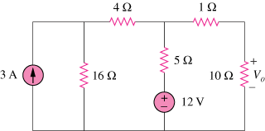

Figure 4.105
For Prob. 4.38.

Solution

We find Thevenin equivalent at the terminals of the 10-ohm resistor. For R_{Th}, consider the circuit below.
1
4

5

R_{Th}
16

For V_{Th}, consider the circuit below.
1
V₁ 4 V₂

5 +

3A 16 V_{Th}
+ ₋
12 V
-

At node 1,
(1)
At node 2,
(2)
Solving (1) and (2) leads to
Thus, the given circuit can be replaced as shown below.

5

+ +
19.2V V_{o} 10
- -

Using voltage division,

= 12.8 V.

